**Working Document: obesity**

***Machine Learning Mastery | Arthurlot Li***

**I. Description**

This is a working document meant to serve as a companion to written notes generated while solving a particular machine learning problem. All items listed in this document are to be indexed in a standardized manner for easy reference within the written notes. Retain this document and its contents for future use in the generation of a formal report.

**II. Items**

Refer to each numbered item as **working-#** in written notes(“the box plot seen in *working-5* shows...”)

1. Text, whiteboard

   Description automatically generatedChart, scatter chart

   Description automatically generatedChart, scatter chart, bubble chart

   Description automatically generatedChart, scatter chart, bubble chart

   Description automatically generatedText

   Description automatically generated with medium confidenceChart

   Description automatically generatedChart, scatter chart

   Description automatically generatedChart, scatter chart

   Description automatically generatedA picture containing graphical user interface

   Description automatically generatedText, whiteboard

   Description automatically generatedChart

   Description automatically generated with medium confidenceText, whiteboard

   Description automatically generatedChart, scatter chart

   Description automatically generatedChart, scatter chart

   Description automatically generatedChart

   Description automatically generatedChart

   Description automatically generated with medium confidenceA picture containing graphical user interface

   Description automatically generated
2. 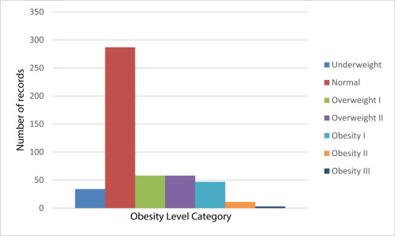’
3. 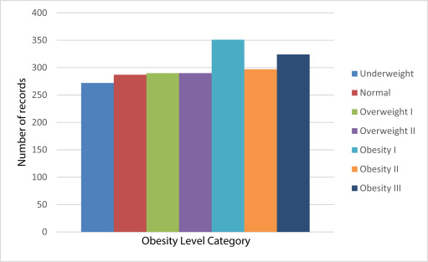
4. Modified Dataset: Text

   Description automatically generatedChart, scatter chart

   Description automatically generatedChart, scatter chart

   Description automatically generatedText

   Description automatically generatedText

   Description automatically generatedChart

   Description automatically generatedText

   Description automatically generatedChart

   Description automatically generated with medium confidenceText

   Description automatically generatedA picture containing text

   Description automatically generatedText

   Description automatically generated with medium confidenceChart

   Description automatically generatedText

   Description automatically generatedChart

   Description automatically generatedChart, scatter chart

   Description automatically generatedGraphical user interface

   Description automatically generated with low confidence